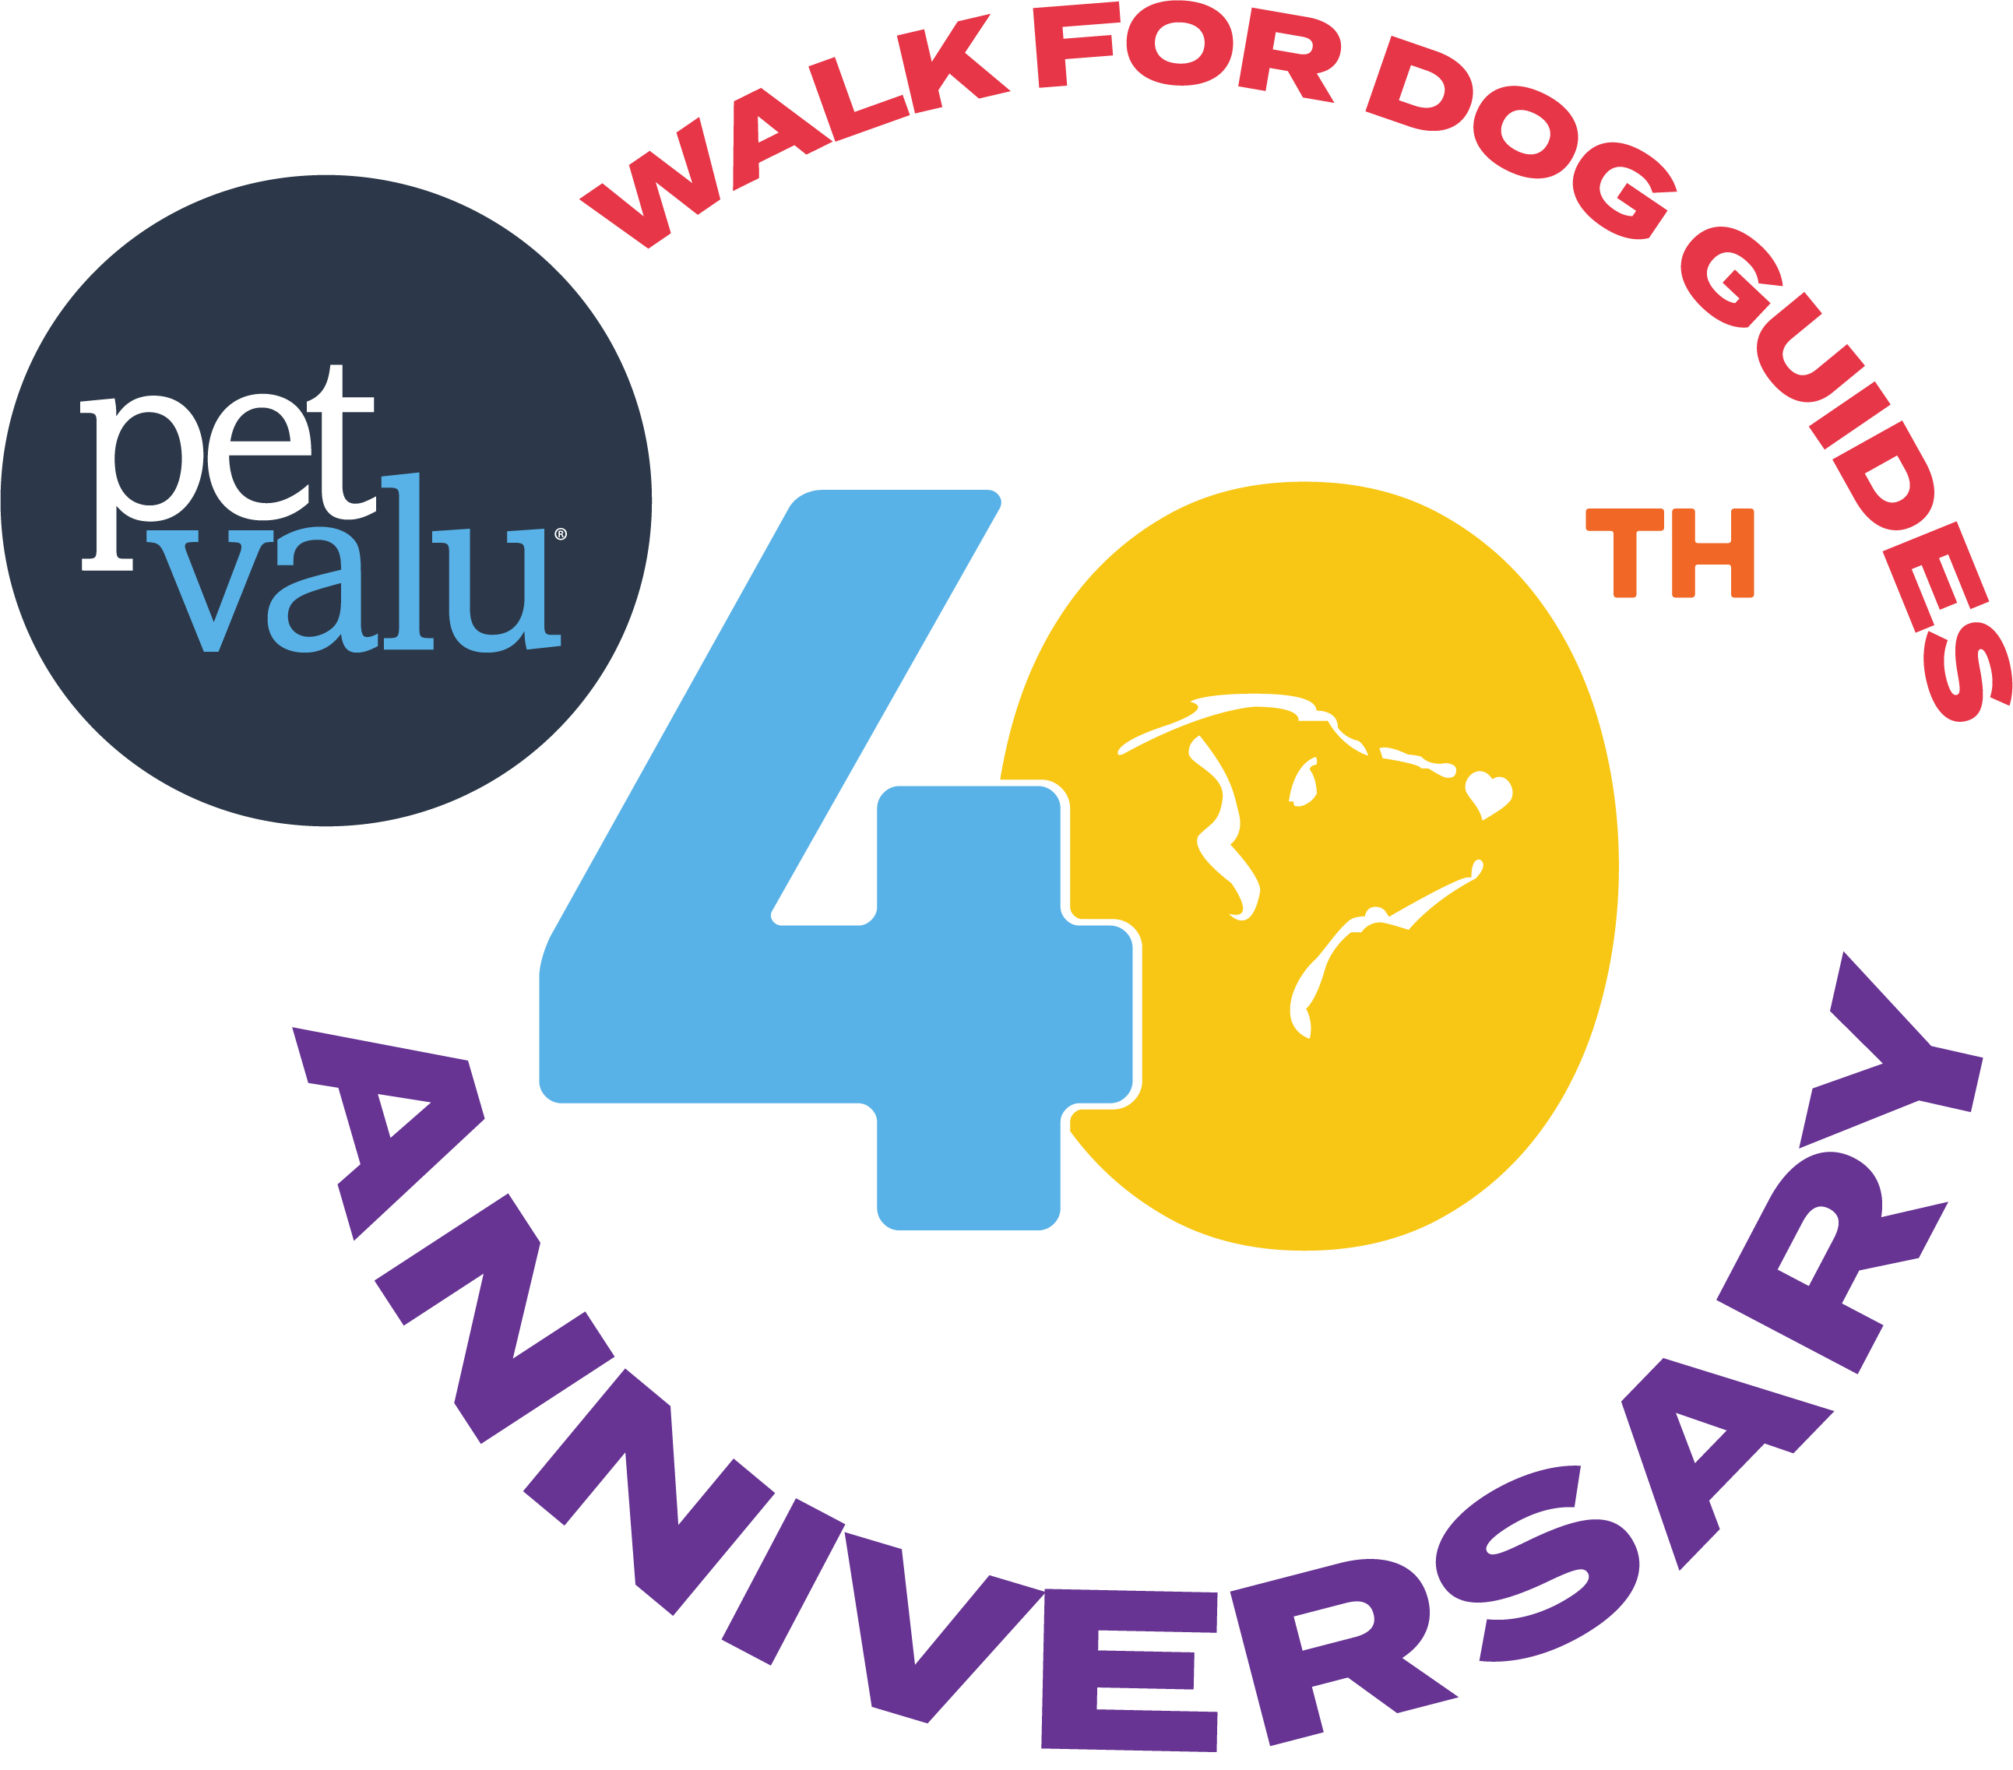

**Caption Guide**

**General Post:**

Join us for the Pet Valu Walk for Dog Guides!

This event raises funds to provide life-changing Dog Guides to Canadians with disabilities. Each Dog Guide costs $35,000, but thanks to donors, they’re provided at no cost to the recipient.

Register for the Pet Valu Walk for Dog Guides on Sunday, May 25, 2025, or find a local event at [www.walkfordogguides.com](http://www.walkfordogguides.com/)

Let’s walk together for a brighter and more inclusive future!

USE IMAGES PROVIDED IN THE RESOURCE SECTION

**Countdown Posts**

3 Week Countdown:

3 Weeks to Go! Let's Walk Together Toward a Future of Endless Possibilities

n just three weeks, we’ll be walking together for the Pet Valu Walk for Dog Guides, empowering Canadians with disabilities by providing life-changing Dog Guides at no cost.

Ready to make an impact? Visit [www.walkfordogguides.com](https://www.walkfordogguides.com) to learn more and register for a Walk near you!

USE IMAGES PROVIDED IN THE RESOURCE SECTION

### 2 Week Countdown:

Two Weeks Until We Walk for Dog Guides!

Only two weeks until the Pet Valu Walk for Dog Guides! Join us in supporting Canadians with disabilities by walking, fundraising, or donating. Your participation makes a lasting impact. Each Dog Guide costs $35,000, but thanks to donors, they’re provided at no cost to the recipient.

Here’s how to get involved:

✔️ Sign up for your local Walk: [www.walkfordogguides.com](https://www.walkfordogguides.com)

✔️ Spread the word with posters and graphics: [walkfordogguides.com/resources](https://walkfordogguides.com/resources)

✔️ Make a donation and help us reach our $1.6 million goal!

Join us on Sunday, May 25, 2025!

Let’s walk together — for independence, for inclusion, for the future.

USE IMAGES PROVIDED IN THE RESOURCE SECTION

### 10 Day Countdown:

10 Days Until We Walk!

The big day is almost here! In just 10 days, we'll be walking to provide life-changing Dog Guides to Canadians with disabilities. Every step supports the Lions Foundation of Canada and unlocks a future of possibilities!

Join us or the Pet Valu Walk for Dog Guides on Sunday, May 25, 2025, or find a local Walk near you! Register today at [www.walkfordogguides.com](https://www.walkfordogguides.com)

Let’s walk together for a future full of possibility!

USE IMAGES PROVIDED IN THE RESOURCE SECTION

### 9 Day Countdown:

9 Days Until We Walk for Dog Guides!

We're just nine days away from the Pet Valu Walk for Dog Guides! Your support helps provide Dog Guides at no cost to Canadians with disabilities.

Join us or the Pet Valu Walk for Dog Guides on Sunday, May 25, 2025, or find a local Walk near you! Register today at [www.walkfordogguides.com](https://www.walkfordogguides.com)

Every dollar helps provide Dog Guides to Canadians with disabilities, at no cost to them.

USE IMAGES PROVIDED IN THE RESOURCE SECTION

### 8 Day Countdown:

8 Days Until the Pet Valu Walk for Dog Guides!

Only eight days left until we walk to empower Canadians with disabilities. Your participation helps provide life-changing Dog Guides. Join us or the Pet Valu Walk for Dog Guides on Sunday, May 25, 2025, or find a local Walk near you!

Register today at [www.walkfordogguides.com](https://www.walkfordogguides.com)

Together, let’s walk for a more supportive and inclusive future!

USE IMAGES PROVIDED IN THE RESOURCE SECTION

### 1 Week Countdown:

1 Week Until We Walk for Dog Guides!

In just one week, we’ll be stepping up to support Canadians with disabilities. Each Dog Guide costs $35,000—but thanks to generous donors, they're provided free of charge. This 40th anniversary will be one to remember!

Join the Pet Valu Walk for Dog Guides on Sunday, May 25, 2025, or find a local Walk near you: [www.walkfordogguides.com](https://www.walkfordogguides.com)

How to get involved:

✔️ Sign up for your local Walk

✔️ Spread the word with posters and graphics: [walkfordogguides.com/resources](https://walkfordogguides.com/resources)

✔️ Make a donation and help us reach our $1.6 million goal!

Let’s walk toward a more inclusive future—together.

USE IMAGES PROVIDED IN THE RESOURCE SECTION

### 6 Day Countdown:

6 Days to Go Until the Pet Valu Walk for Dog Guides!

Only six days left until the Pet Valu Walk for Dog Guides! Your support helps provide Dog Guides at no cost to Canadians with disabilities. Let's walk together for a brighter future.

Join us or the Pet Valu Walk for Dog Guides on Sunday, May 25, 2025, or find a local Walk near you! Register today at [www.walkfordogguides.com](https://www.walkfordogguides.com)

Every dollar helps provide Dog Guides to Canadians with disabilities, at no cost to them.

USE IMAGES PROVIDED IN THE RESOURCE SECTION

### 5 Day Countdown:

5 Days to go! Let’s step toward a brighter future and endless possibilities!

We're just five days away from the Pet Valu Walk for Dog Guides! Join us in walking to provide life-changing Dog Guides to Canadians with disabilities. Every step counts.

Register today at [www.walkfordogguides.com](https://www.walkfordogguides.com)

Here’s how to get involved:

✔️ Sign up for your local Walk

✔️ Spread the word with posters and graphics: [walkfordogguides.com/resources](https://walkfordogguides.com/resources)

✔️ Make a donation and help us reach our $1.6 million goal!

Let’s walk toward a brighter, more inclusive future — together.

USE IMAGES PROVIDED IN THE RESOURCE SECTION

### 4 Day Countdown:

4 Days to Go Until the Pet Valu Walk for Dog Guides!

The countdown is on! In just four days, we’ll be walking to support Canadians with disabilities and help provide Dog Guides at no cost to those who need them. Every step brings someone closer to greater independence and confidence.

Ready to make an impact?  
Find a Walk near you and sign up today at [www.walkfordogguides.com](https://www.walkfordogguides.com)

Let’s walk together for a future full of possibility!

USE IMAGES PROVIDED IN THE RESOURCE SECTION

### 3 Day Countdown:

3 Days Until We Walk for Dog Guides!

The big day is almost here! In just three days, we'll be walking to support Canadians with disabilities. Your participation helps provide Dog Guides at no cost.

Join us or the Pet Valu Walk for Dog Guides on Sunday, May 25, 2025, or find a local Walk near you!

✔️ Sign up for your local Walk

✔️ Spread the word with posters and graphics: [walkfordogguides.com/resources](https://walkfordogguides.com/resources)

✔️ Make a donation and help us reach our $1.6 million goal!

Register today at [www.walkfordogguides.com](https://www.walkfordogguides.com)

USE IMAGES PROVIDED IN THE RESOURCE SECTION

### 2 Day Countdown:

Only 2 Days to Go!

The Pet Valu Walk for Dog Guides is almost here—and this 40th anniversary celebration will be one to remember!

On Sunday, May 25, we walk to help provide life-changing Dog Guides at no cost to Canadians with disabilities.

Be part of something powerful—every step brings someone closer to independence.

Find a Walk near you and register today at [www.walkfordogguides.com](https://www.walkfordogguides.com)

USE IMAGES PROVIDED IN THE RESOURCE SECTION

Day Before Countdown:

Just 1 Day to Go!

Tomorrow marks the 40th anniversary of the Pet Valu Walk for Dog Guides—and it’s going to be unforgettable!

We’re walking to create brighter futures and unlock new possibilities for Canadians living with disabilities.

It’s not too late to be part of it! Register now at [www.walkfordogguides.com](https://www.walkfordogguides.com)

USE IMAGES PROVIDED IN THE RESOURCE SECTION

Day of Countdown:

Today’s the Day!

The Pet Valu Walk for Dog Guides is finally here—and we’re walking to make a real difference!

Every dollar raised supports the Lions Foundation of Canada Dog Guides, helping match Canadians with disabilities to life-changing Dog Guides trained in seven specialized programs.

There's still time to join the mission—find your local Walk or make a donation today at [www.walkfordogguides.com](https://www.walkfordogguides.com)

Thank you to everyone who has donated so far. Your support helps unlock a future full of confidence, independence, and possibility.

Let’s walk with purpose—together!

USE IMAGES PROVIDED IN THE RESOURCE SECTION

**7 Program Walk Stars**

Service team Karen Collard and Piper:

Meet Karen and Piper, an incredible team from our Service program!

Dog Guides is the only organization supporting 7 life-changing programs. When you walk, you help raise the funds needed to create matches like Karen and Piper.

Learn more about their special bond, or sign up to donate and participate at [www.walkfordogguides.com](https://www.walkfordogguides.com)

Hearing team Jacob and Zenith:

Meet Jacob and Zenith, an inspiring team from our Hearing program!

Dog Guides is the only organization offering 7 life-changing programs. By participating in the walk, you help raise the funds needed to create meaningful partnerships like Jacob and Zenith.

Discover their special bond or sign up to donate and take part at [www.walkfordogguides.com](https://www.walkfordogguides.com)

Canine Vision team Barb and Mango:

Meet Barb and Mango, a remarkable duo from our Canine Vision program!

Dog Guides is the only organization providing seven life-changing programs. When you join the walk, you help fund the training and matching of life-changing teams like Barb and Mango.

Learn more about their incredible bond or sign up to donate and participate at [www.walkfordogguides.com](https://www.walkfordogguides.com)

Seizure Response team John and Dexter:

Meet John and Dexte**r**, a remarkable duo from our Seizure Response program!

Dog Guides is the only organization providing seven life-changing programs. When you join the walk, you help fund the training and matching of life-changing teams like John and Dexter.

Learn more about their incredible bond or sign up to donate and participate at [www.walkfordogguides.com](https://www.walkfordogguides.com)

Facility Support team Jennifer and Zane:

Meet Jennifer and Zane, a remarkable duo from our Facility Support program!

Dog Guides is the only organization providing seven life-changing programs. When you join the walk, you help fund the training and matching of life-changing teams like Jennifer and Zane.

Learn more about their incredible bond or sign up to donate and participate at [www.walkfordogguides.com](https://www.walkfordogguides.com)

Diabetes Alert team Emma and Ecco:

Meet Emma and Ecco, an incredible duo from our Diabetes Alert Dog program!

Dog Guides is the only organization providing seven life-changing programs. When you join the walk, you help fund the training and matching of life-changing teams like Jennifer and Zane.

Learn more about their incredible bond or sign up to donate and participate at [www.walkfordogguides.com](https://www.walkfordogguides.com)

Autism Assistance team Alison and Buttons + Her Mother Jodie

Meet Alison, her Dog Guide Buttons, and her mother Jodie—an inspiring team from our Autism Assistance Program!

Dog Guides is the only organization providing seven life-changing programs. When you join the walk, you help fund the training and matching of life-changing teams like Jennifer and Zane.

Learn more about their incredible bond or sign up to donate and participate at [www.walkfordogguides.com](https://www.walkfordogguides.com)